Statistical analysis
To quantify mechanical accuracy, a geometric transformation was applied to express all measurements in a common Cartesian framework, as the measured depth does not directly correspond to the Cartesian Z coordinate of the testing platform. Errors in the X and Y axes were calculated as the difference between observed and true positions. For the Z component, error was derived from the depth deviation along the trajectory ($D_{err}$) and the collar angle ($θ$), such that the Cartesian Z error was defined as $z_{err}=D_{err}⋅sin⁡(θ)$. The three-dimensional Euclidean error was then computed as:
$$E_{3D}=\sqrt{x_{err}^{2}+y_{err}^{2}+{\left(D_{err}⋅sin⁡(θ)\right)}^{2}}$$
Write that this can be interpreted as weighted Euclidean error – explain how. The $sin⁡(θ)$ is the alpha in that case
The inter-observer error was calculated as the root mean square error:
$$RMSE=\sqrt{\frac{1}{n}\sum_{i=1}^{n}{{\left(μ_{i}-X_{i}\right)}^{2}}}$$

Data normality was assessed using the Shapiro–Wilk test prior to parametric analyses. Given the small sample sizes, a one-way analysis of variance (ANOVA) was performed, and for results with p < 0.05, post hoc Tukey tests were applied with a familywise significance level of 0.05.

Results
The system work envelope spanned translational ranges of Y = 70–170 mm and X = 60–140 mm, with angular ranges of the collar (50–90°) and arc (55–125°). In a cohort of ventricular catheter placements (N = 17), all recorded coordinates fell within these limits (Table 1).
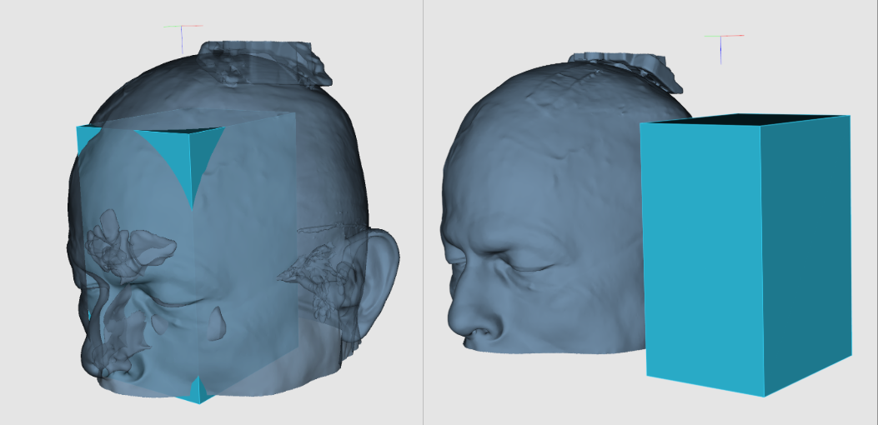
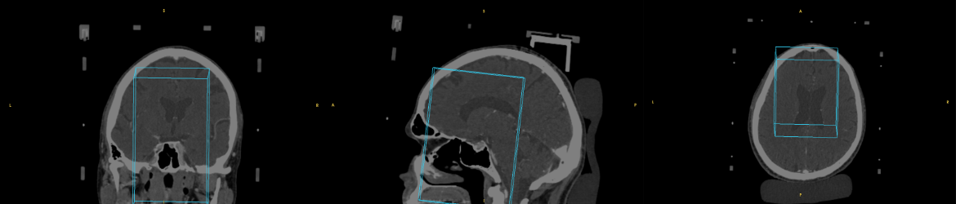

Work envelope
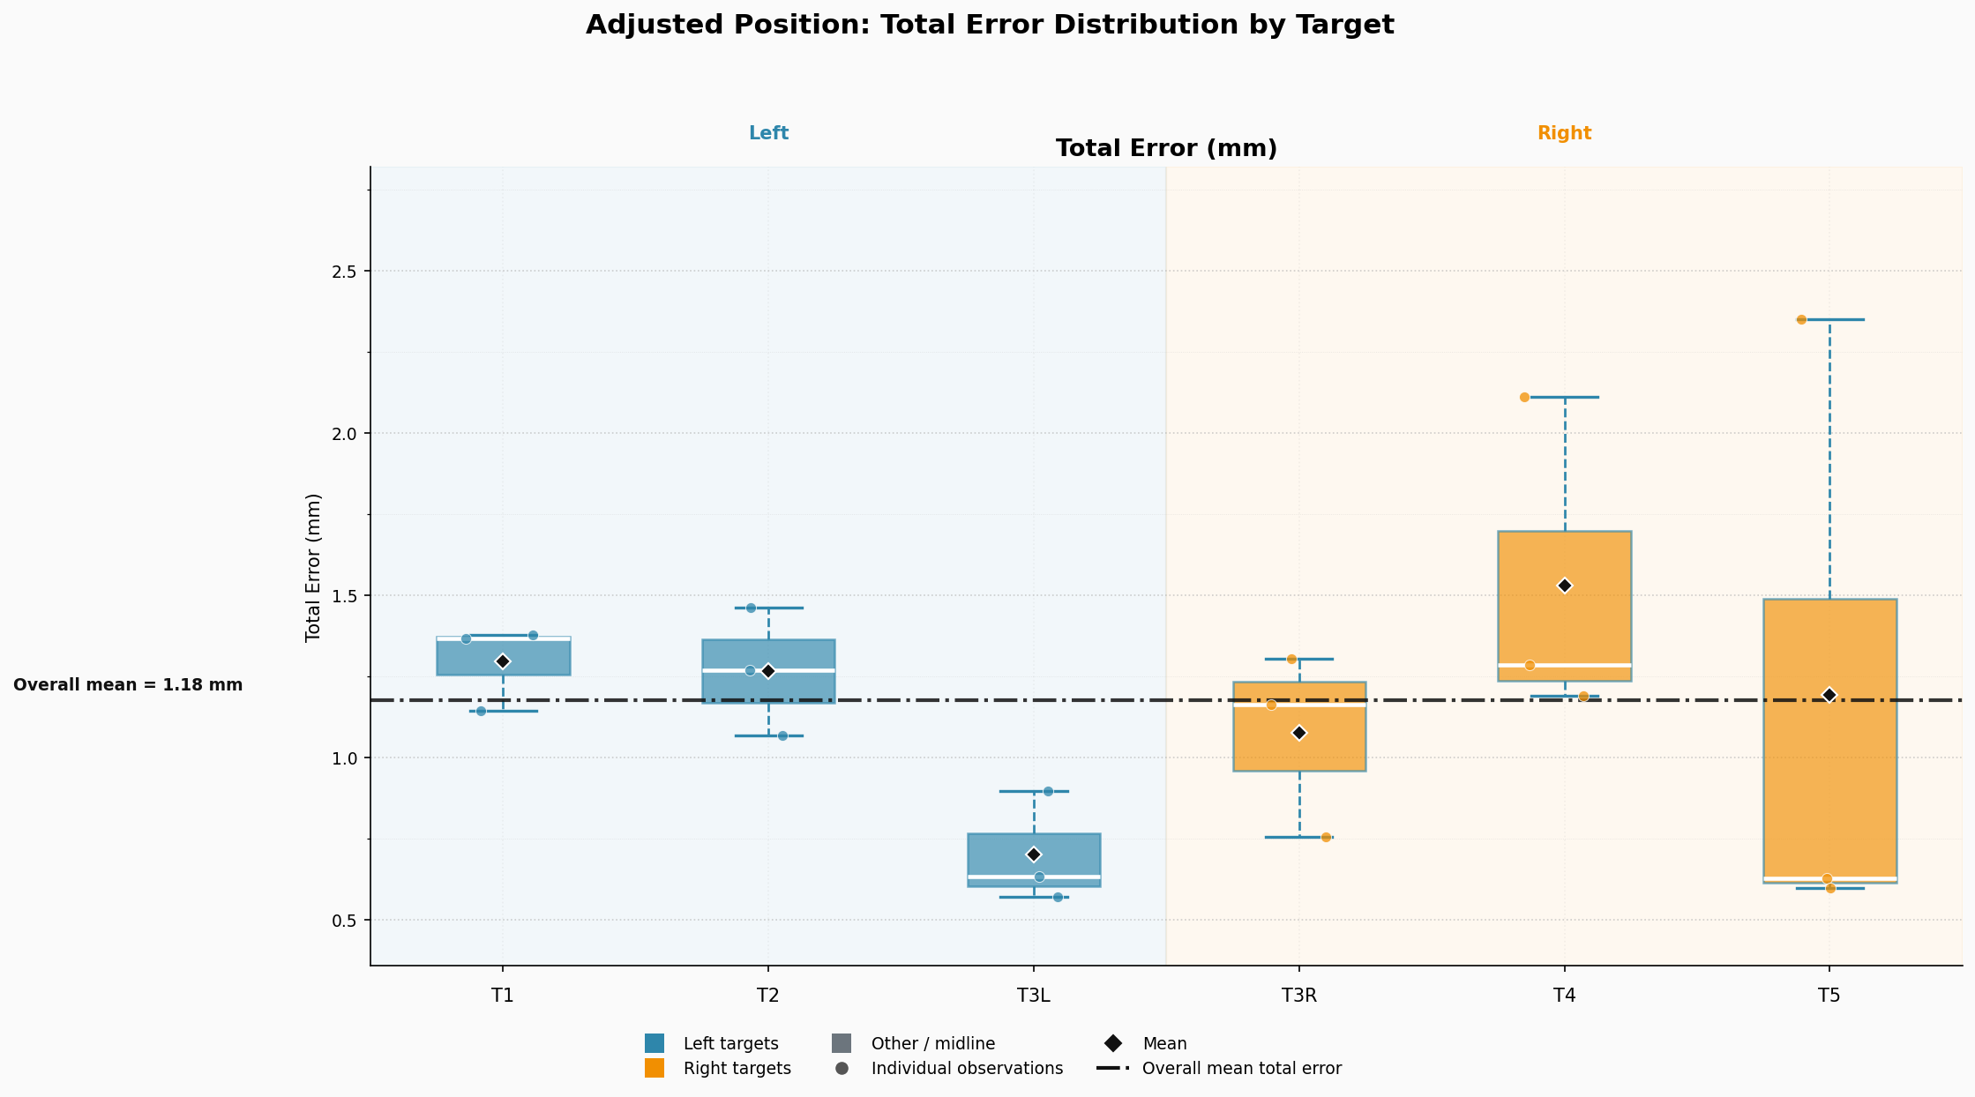
The average mechanical error was xx ± xx mm across five target points on a calibrated testing platform (Figure 3A- adjusted).

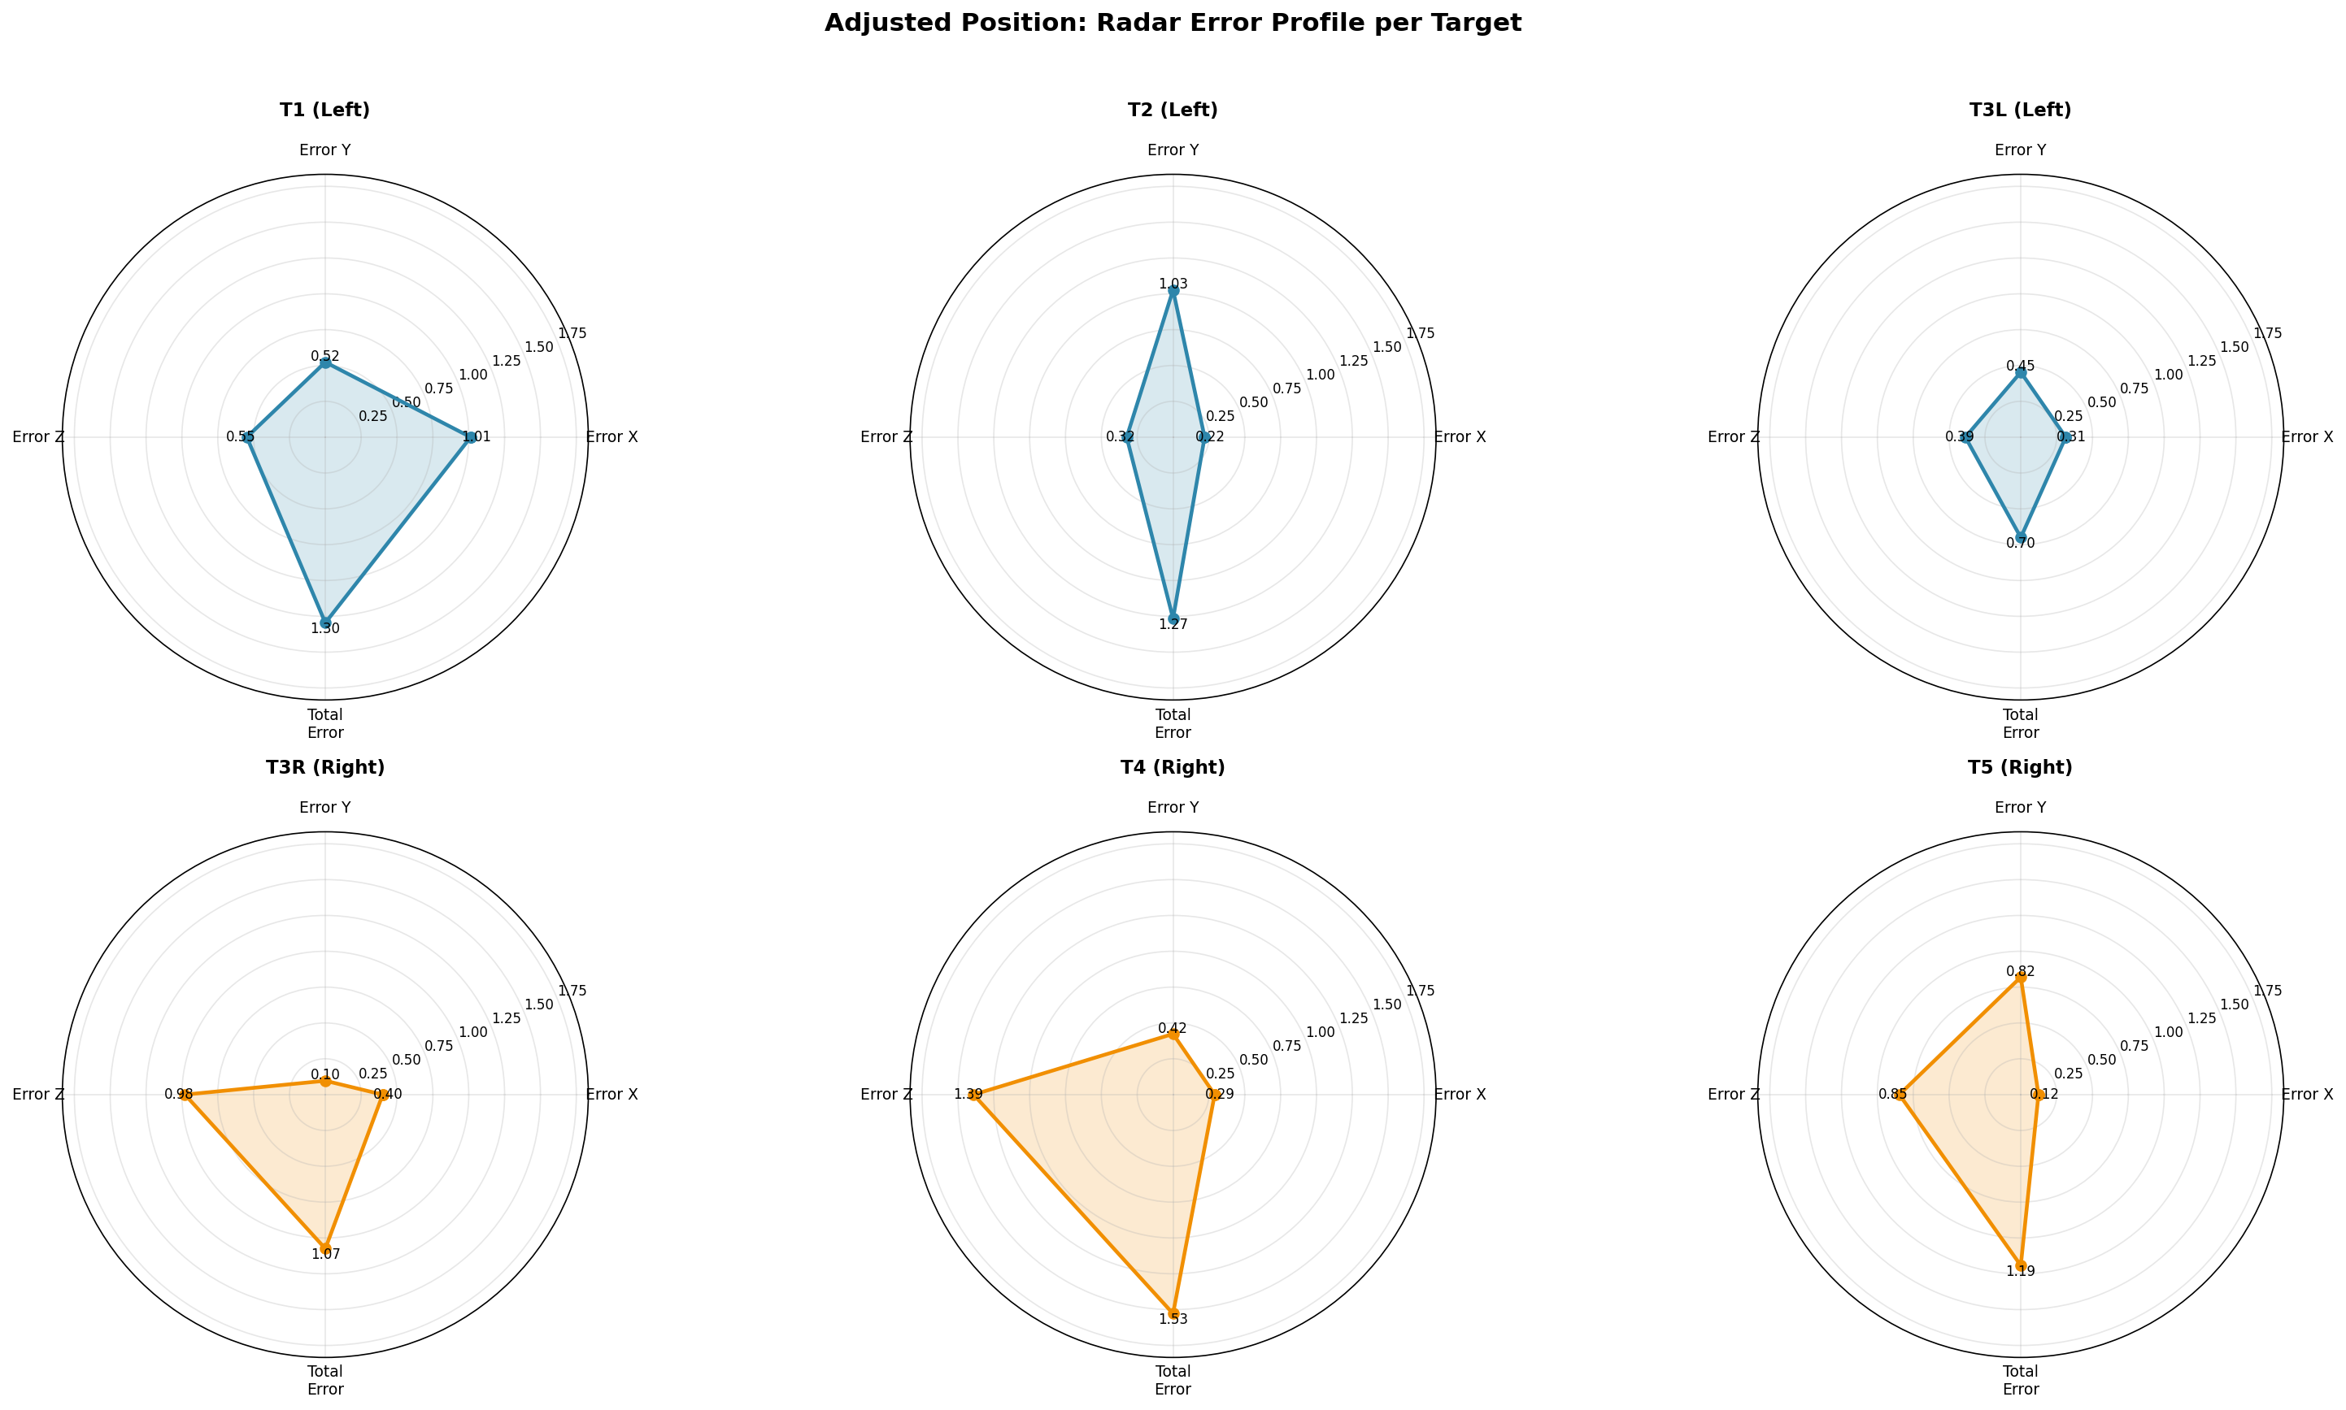
Mechanical error per target
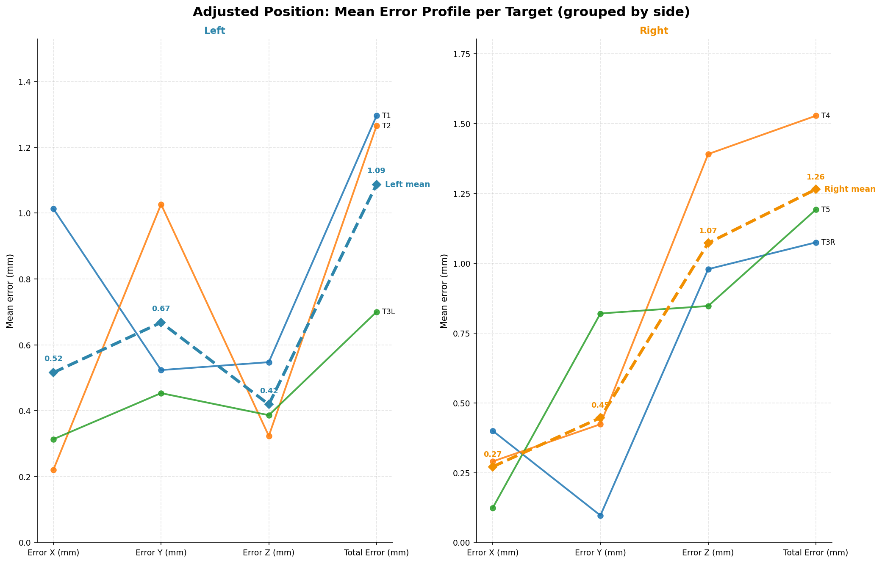Mechanical error left vs right

Mechanical error using the Z adapters, the error was xx ± xx mm across 5 target points (Figure 3B).
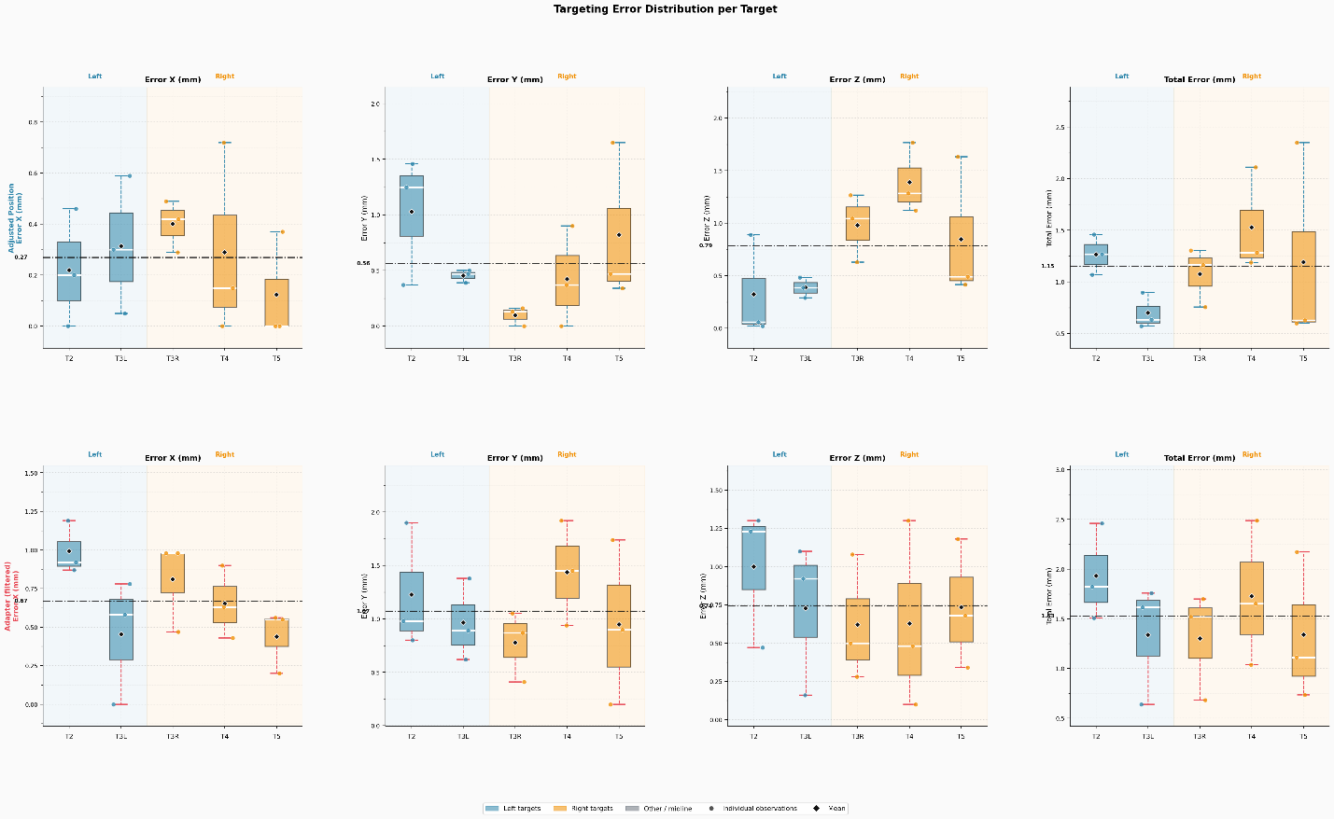
Mechanical error calculated distance vs adapters total and per target

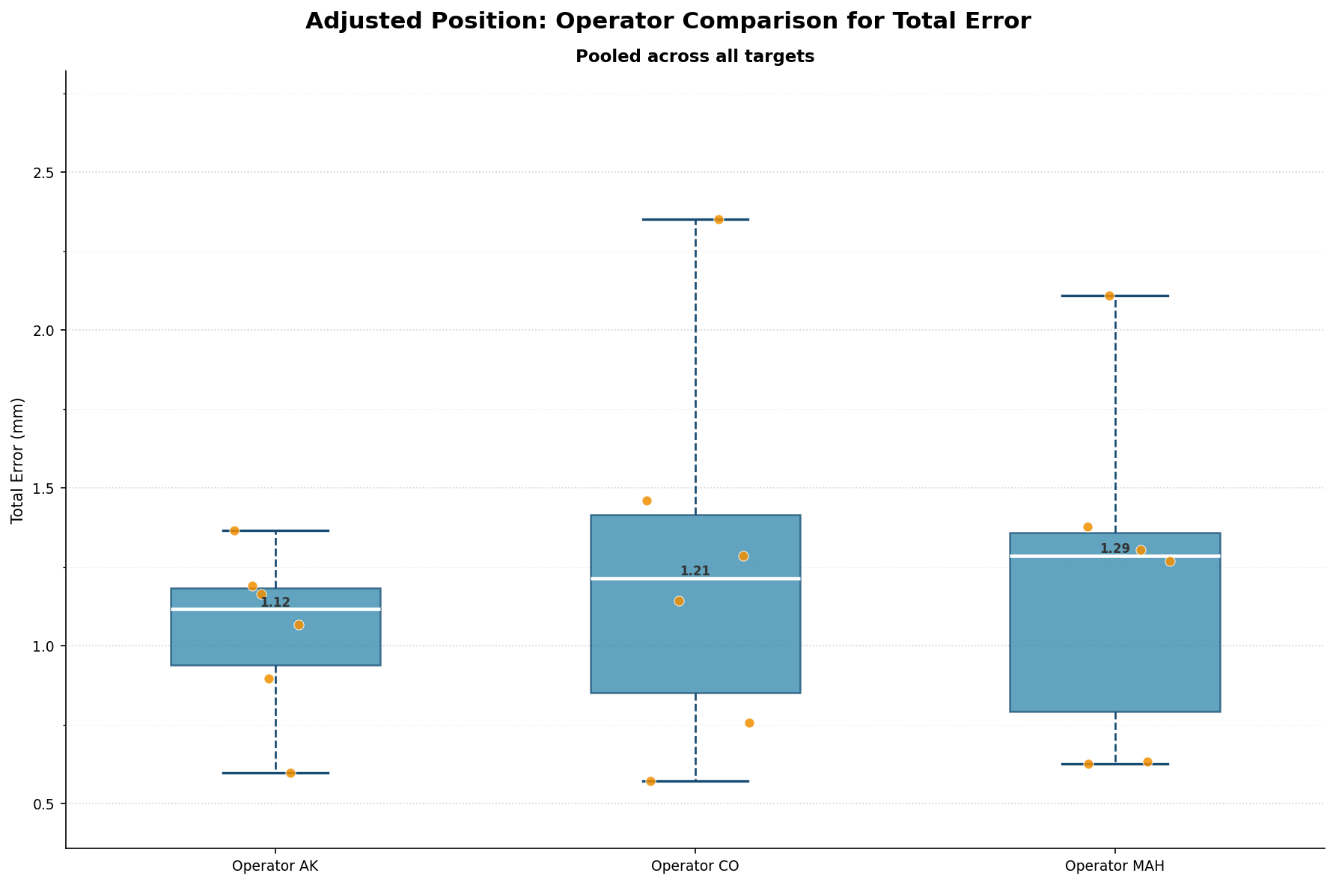
Inter-observer error (RMSE)

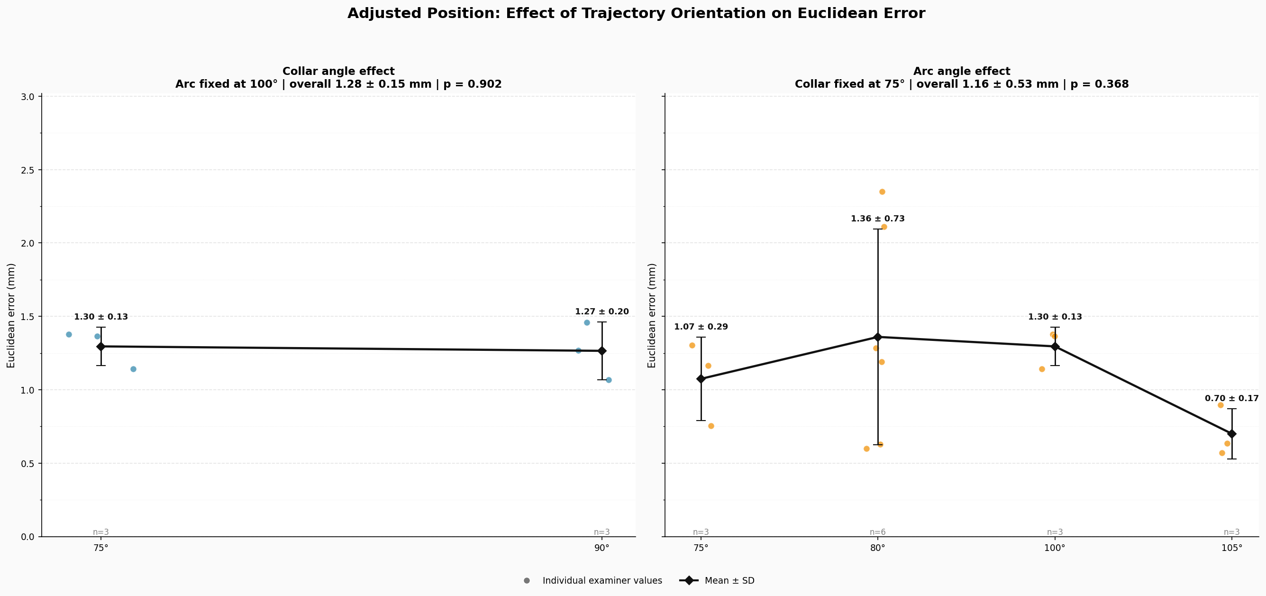
To examine the effect of trajectory orientation on targeting accuracy, collar and arc angles were systematically varied. For the CFP frame, angular adjustments produced mean Euclidean errors of xx ± xx mm and xx ± xx mm for collar and arc angles, respectively (Fig. X, n = 3 examiners). No statistically significant variation in targeting error was observed across the full angular range

Results for:
Data normality was assessed using the Shapiro–Wilk test prior to parametric analyses. Given the small sample sizes, a one-way analysis of variance (ANOVA) was performed, and for results with p < 0.05, post hoc Tukey tests were applied with a familywise significance level of 0.05.
- Attached as a markdown file report

